STUDENT HOSTEL PORTAL
@CREATIVITY THINK (9483175986/7019689991)

ABSTRACT:
Student Hostel Portal is a web application designed to streamline hostel operations for colleges, PG homes, and student accommodations. Users can apply for hostel allotment, pay fees, view timetables and notices, submit leave applications, and access dashboards for tracking their activities. Administrators manage student records, room assignments, fee collection, leave requests, notices, and analytics dashboards. Built with Django and Django Rest Framework for backend operations and React with Redux and Chart.js for frontend interfaces, the portal ensures efficient accommodation management, transparent fee tracking, and centralized communication between hostel residents and administration..

INTRODUCTION OF THE PROJECT:
Managing student hostels manually can be complex and error-prone, involving room allocation, fee collection, leave approvals, and communication of notices. Student Hostel Portal provides a centralized web platform where students can apply for hostels, pay fees, view timetables and notices, submit leave applications, and access dashboards. Administrators oversee student records, manage rooms, track fee payments, approve leaves, send notices, and analyze data through dashboards. Using Django for backend services and React with Redux and Chart.js for interactive dashboards, the system ensures transparency, efficiency, and better communication between residents and administrators..

PROJECT OBJECTIVES:

• Provide an online system for hostel room allotment
• Facilitate fee payments and financial tracking
• Enable students to view timetables and notices
• Allow submission and tracking of leave applications
• Give administrators control over student management, rooms, and fees
• Generate analytics dashboards for operational insights
• Improve communication via notices and announcements

PROBLEM OF THE STATEMENT:
Manual hostel management involves numerous administrative tasks, such as room allocation, fee collection, leave approval, timetable updates, and communication of notices. These processes are time-consuming and prone to errors. Student Hostel Portal addresses these challenges by providing a centralized, web-based system for managing student accommodations efficiently. Students gain easy access to hostel services, fee payments, timetables, notices, and leave applications, while administrators manage operations, track analytics, and communicate seamlessly. This system ensures streamlined, accurate, and transparent hostel management..

MOTIVATION OF THE PROJECT:
• Streamline hostel room allocation and management
• Simplify fee collection and tracking processes
• Facilitate leave applications and approvals
• Provide clear communication via noticeboard and dashboards
• Offer analytics for informed administrative decisions

BLOCK DAIGRAM OF PROJECT:

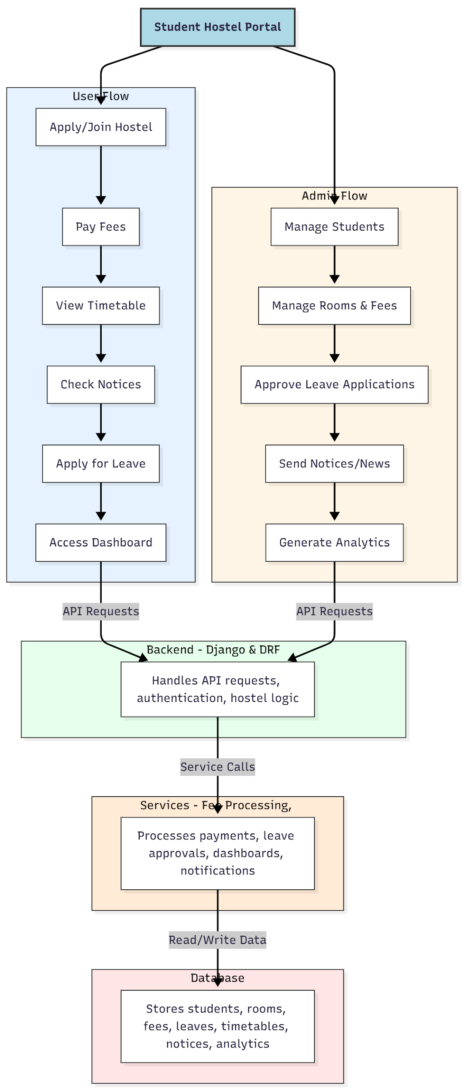

WORKING OF THE PROJECT:
Students apply for hostels, pay fees online, view timetables and notices, submit leave applications, and access dashboards for tracking their activities. The backend handles authentication, API requests, and hostel management logic. Services manage fee processing, leave approvals, notice dissemination, and analytics dashboards. Administrators manage student records, room allocations, fee collection, leave requests, notices, and analytics dashboards. This system ensures accurate, efficient, and transparent management of hostel operations for both residents and administrators..

SOFTWARE REQUIREMENT:
- Backend:
  - Python 3.x
  - Django
  - Django REST Framework
  - SQLite/PostgreSQL
- Frontend:
  - Node.js and npm
  - React.js
  - Axios
- Development Tools:
  - Visual Studio Code
  - Postman (for testing APIs)
  - Git/GitHub (for version control)
- Server/Deployment (Optional):
  - Gunicorn, Nginx, or Heroku/AWS for hosting

ADVANTAGES OF THE PROJECT:

• Streamlines hostel room allocation and management
• Simplifies fee collection and tracking
• Facilitates leave applications and approvals
• Provides dashboards for students and admins
• Centralizes notices and announcements
• Generates analytics for better decision-making
• Reduces manual errors in hostel operations
• Enhances communication and operational transparency

APPLICATIONS OF THE PROJECT:
• College and university hostels
• PG accommodations
• Student dormitories
• Hostel fee management systems
• Leave management systems
• Student dashboards for schedules and notices
• Administrative dashboards for analytics
• Communication of news and alerts

REFERENCES:

- Django REST Framework Documentation — Django Software Foundation. Django Documentation. Available: https://docs.djangoproject.com/
- Django REST Framework. DRF Documentation. Available: https://www.django-rest-framework.org/
- React. React Official Documentation. Available: https://reactjs.org/docs/getting-started.html
- Redux. Redux Documentation. Available: https://redux.js.org/introduction/getting-started
- PostgreSQL Global Development Group. PostgreSQL Documentation. Available: https://www.postgresql.org/docs/
- MySQL. MySQL Reference Manual. Available: https://dev.mysql.com/doc/
- Git. Git Documentation. Available: https://git-scm.com/doc
- Node.js. Node.js Documentation. Available: https://nodejs.org/en/docs/
- Axios. Axios Documentation. Available: https://axios-http.com/docs/intro
- Socket.io Documentation – https://socket.io/docs/

